Report of the
New England Wind Lease Area Transit Corridor Workshop
Warwick, RI, October 31, 2018

Summary: A workshop to discuss transit lanes for fishing vessels through the wind farms in the Massachusetts Wind Energy Area was held in Warwick, RI, on October 31, 2018. It was organized by the recently formed Responsible Offshore Development Alliance (RODA). It was attended by fishermen and representatives of fishermen’s advocacy groups, federal government officials from the Bureau of Oceans Affairs, National Marine Fisheries Service and US Coast Guard, officials from Massachusetts and Rhode Island government agencies and representatives for Deepwater Wind, Bay State Wind and Vineyard Wind, the three companies that have leased wind energy areas south of Martha’s Vineyard.
Two main topics were discussed: 1) the location and width of transit lanes through the wind farms, and 2) fishermen’s expectations for mitigation due to loss from the construction and operation of wind farms.
Workshop members did not reach agreement on the location or width of transit lanes. A small working group will be formed to consider the matter further.
The workshop participants developed a list of ideas about ways to mitigate the impacts of developing wind farms. Fishermen did not share a common view on how to be compensated for loss. Some supported payments directly to vessel owners to compensate for increased costs of doing business. Others an approach that benefitted the entire fishing community might be better, since it might be difficult to determine the extent of losses and who was affected by the wind farms.

Background:
I. Transit Lanes
Transit lanes are straight paths where the turbines are placed farther apart to allow safer passage through a wind farm. The three wind development companies that currently hold leases in the Massachusetts Wind Energy Area have agreed in principle to include at least one transit lane through some section of their wind farms, but there is still debate on the location and the width of the lanes. Wind companies seek to maximize the efficiency of the turbine layout and supporting structures. Some proposed transit lanes go right through valuable bottom which wind companies were counting on the place their turbines. In the case of Bay State Wind, one proposed transit lane runs right through the place where it had planned to put one of two substations—structures at which all the electricity produced by the turbines is collected and routed to shore. If the substation has to be moved, then the cable layout would need to be planned again, a proposition that could require additional bottom surveys and significant expense.
On September 20, 2018, the Massachusetts Fisheries Working Group (FWG) met to discuss transit lanes. After a long discussion, the FWG came to consensus on a pattern of transit lanes through the Massachusetts wind energy area lease sites. Unfortunately, not all wind developers and not all fisheries had representatives at the September 20 discussion, and the “consensus” recommendations developed by the FWG turned out to be not acceptable to others. The purpose of the October 31, 2018 workshop was to bring a larger group of organizations, including all three wind development companies that hold leases in the Massachusetts Wind Energy Area (Deepwater Wind, Bay State Wind and Vineyard Wind) to discuss transit lanes.
II. Mitigating impacts on fishermen
The meeting organizers took advantage of the presence of many fishermen and all three wind energy companies to initiate a discussion on how wind companies and/or the government can mitigate, or offset, the impacts of wind farm development on fishermen. This is a difficult and complex issue, and it has not yet been included as a focus of public discussions. Possible methods include direct compensation for financial losses, but mitigation measures could also encompass including transit lanes so that vessels do not have to go all the way around a wind farm. There are many aspects to be discussed including:
- Who is responsible for losses? For example, if a fishing vessel loses power in a wind farm and hits a turbine, who is at fault? If a captain collides with another vessel because the turbines interfered with his radar signal, who is at fault there?
- What form should mitigation or compensation take? Should compensation go only to those who can demonstrate a decline in income? Should the entire fishing community be compensated somehow?
- What kinds of losses should be compensated? Should fishermen who are displaced from fishing in a wind farm area be compensated? Should fishermen who see an influx of such displaced fishermen into their area be compensated? Should captains who chose to sail around a wind farm for safety reasons instead of through it be compensated for extra time and fuel?
The October 31 workshop was not intended as an effort to reach consensus on mitigation techniques. Instead, it was a way for fishermen to get some of their views about mitigation on the record in order to start a public conversation about these complicated questions.

Workshop Report
A. Transit Lanes: The workshop began with a discussion of the September 20 “consensus” recommendations from the Massachusetts Fisheries Working Group. (The consensus recommendations can be seen in Figure 1 below) Under this scenario, all transit lanes would be 2 nautical miles (nm) wide. Fishermen in the room said that 4 nm is the minimum that should be considered for transit lanes, both to provide adequate sea room and to reduce the impact on radars from back scatter from nearby turbines. Wind developers agreed in principle to including transit lanes through their turbines, but they did not commit to any particular width, even to the consensus 2 nm width.
Several alternatives to the original recommended lanes were proposed by wind developers. Each of these new alternatives was discussed in detail, and the advantages and disadvantages identified. Figures 2 through 6 show each proposed new alternative transit lane. Three of the five new proposed lanes are in addition to the ones in the September 20 consensus recommendations shown in Figure 1. The other two (Figures 3 and 5) are suggested changes to lanes in the September 20 FWG consensus.
During the discussion of transit lanes, a question was asked as to whether fishing would be allowed in the lanes. A BOEM representative said that there are no plans to prohibit fishing in the wind farms, including in the transit lanes. Fishing in or across the transit lanes would be at the captain’s discretion. A Coast Guard representative said that the Coast Guard did not plan on designating these transit lanes as formal traffic separation scheme areas. That designation would require agreement from the International Maritime Organization, which is a lengthy process. Normal rules of the road would apply in the transit lanes, including the precedence of vessels actively fishing.
Although there was general agreement on the North/South transit lanes, there was no agreement on the Northeast/Southwest lanes at the workshop. A small working group composed of fishermen, wind development company representatives and government officials will meet to consider this matter further. The members of that working group were not identified, but RODA will play a major role on behalf of its constituents.
B. Mitigation measures: The discussion of how to mitigate, or offset impacts of wind farms on fishing was introduced at the end of the day, and it was only intended to start the discussion on this complicated topic. Fishermen at the workshop were asked to say what they thought mitigation should include. There was no clear consensus among fishermen as to the best approach to mitigation. Some suggested cash payments for lost income. Others thought that some sort of community fund would be a fairer approach, and that cash payments could pit one fisherman against another, especially if there were limited funds available for mitigation. Several specific forms of mitigation that would benefit the whole fishing community were mentioned. These included:
- Providing funding for fishermen’s health insurance programs
- Retraining programs
- Grants to develop new gear that would allow fishing to continue in wind farm areas
- Establishing a regional research program that would investigate the impacts of wind farms on fish and on fisheries
One fisherman asked for a buyback program to allow fishermen who have fished in the wind energy area to get out of the fishery if they wish. This might reduce the fishing pressure and allow those who remain to survive. Others commented that a buyback program is difficult to implement successfully. One fishermen was opposed to any buyback program, saying that fishermen want to fish.
The workshop adjourned without resolving questions about how to mitigate the impacts of offshore wind development on fishing. This is sure to be a major topic in the future.

Figures
Possible Transit Lanes under discussion at the workshop

Fig 1. “Consensus” transit lanes recommended by the Massachusetts Fisheries Working Group on September 20.
Proposed transit lanes are shown in yellow. In this figure, each lane is 2 nm wide. A concern for fishermen is that all three proposed lanes converge at a single point, which could lead to traffic congestion. The NW/SE lane goes right through the site of one of the Bay State Wind substations.
In these figures, the red and the orange lease sites (closest to Rhode Island) are held by Deepwater Wind. The dark blue lease site directly south of Martha’s Vineyard is held by Bay State Wind (of which Dong Energy is a partner), and the green site that points toward Nantucket is held by Vineyard Wind. The light blue ands the lavender sites have not yet been leased. There will be an auction of these sites on December 13, 2018.
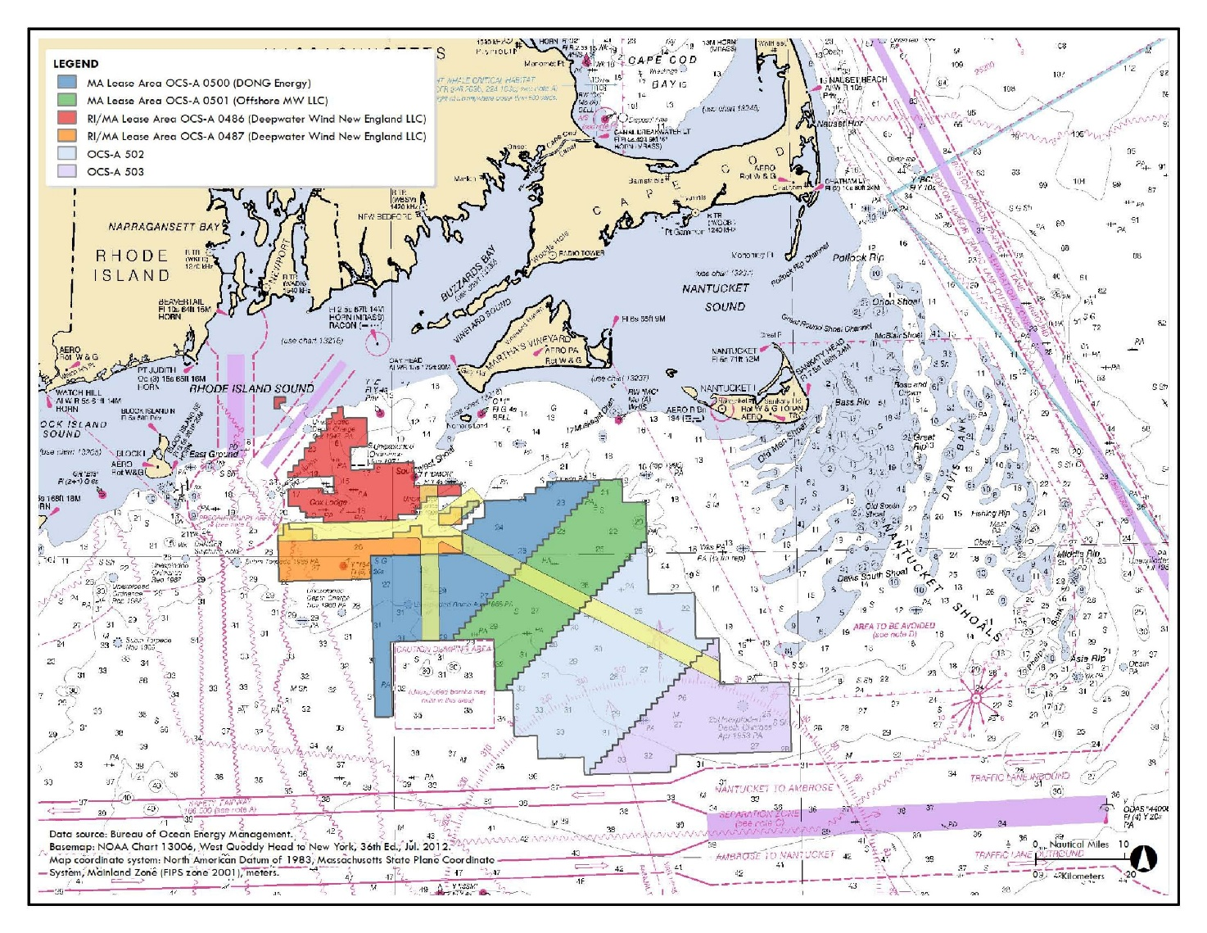

Figure 2. Additional N/S transit lane. (Approximate location shown here in red.)
This would be an additional transit lane that runs N/S. It would be located just to the east of the currently leased wind energy areas and would be helpful for vessels steaming south between Martha’s Vineyard and Nantucket. There were no strong objections from the wind development companies at the workshop, although a BOEM representative stated that it might diminish the value of the unleased blocks.

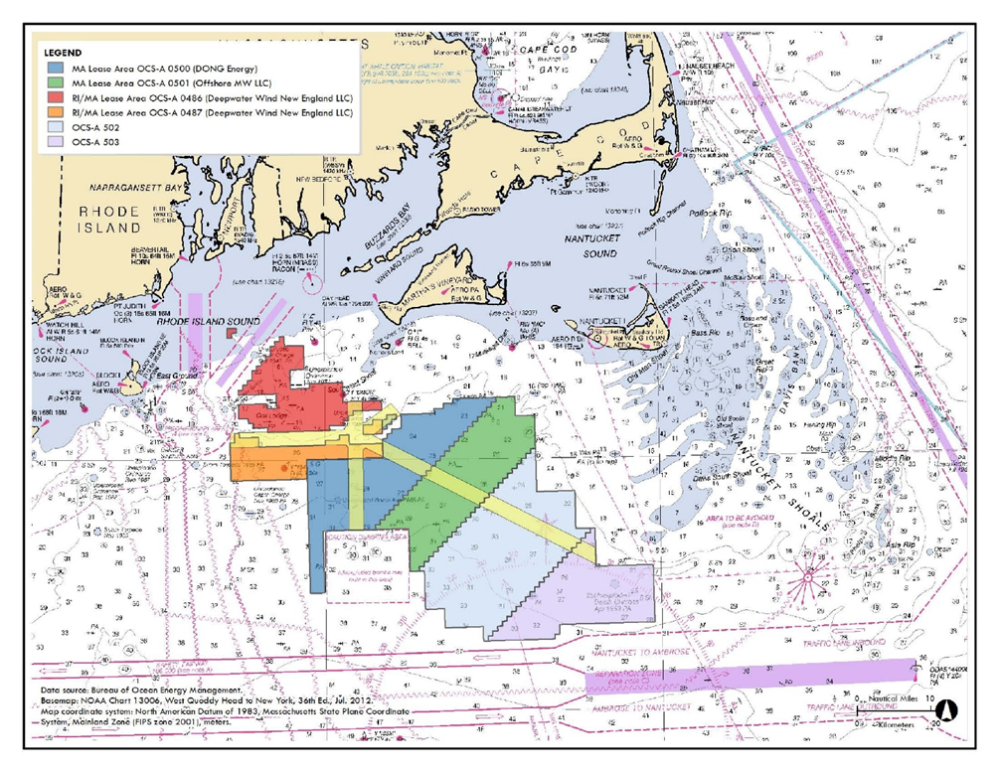

Figure 3. Shift the proposed N/S transit lane to the east. (Approximate location shown here in red.)
The concept here is to move the proposed North/South transit lane about 3 miles to the east. This would give back to Deepwater Wind an important area that is highly valued as a location for turbines. Note that in the configuration shown here, the proposed lane would not cross any Deepwater Wind lease area. This would require vessels using the lane to travel around the Deepwater Wind lease area, then double back. Fishermen pointed out how inconvenient this would be. Deepwater Wind said it would be willing to consider allowing the new transit land to go through its lease area in order to save vessels that extra travel time.

Figure 4. Suggested NW/SE “convenience lane”. (Approximate location shown in red.)
This lane would be one nm wide. Fishermen at the workshop were concerned that 1nm is not sufficient for safe passage in rough weather. Bay State Wind has said that it could agree to a 2 nm-wide lane, but there would be no point in making that change unless Vineyard Wind did the same. The Coast Guard pointed out that, although the lane is narrow and might not be safe in a storm, captains could chose to use this lane in fair weather.

Figure 5. Change the angle of the NW/SE transit lane. (Approximate location shown in red.)
In this proposal, the NE/SW transit corridor proposed by the FWS would be changed to have a different compass heading. Changing the angle of the NW/SE transit lane would help Bay State Wind by avoiding the planned location of its substation. It might also reduce the risk of vessel collision, since it would enter the N/S lane at a different point than the short E/W lane that funnels traffic between the Deepwater Wind lease areas. Most fishermen who spoke to this point said that adding an additional turn to their trip through the wind farms would outweigh the benefit of reduced collision risk. The line remains 2 nm wide.

Figure 6. Additional East/West transit lane. (Approximate location shown here in red.)
This would be an additional two nm-wide lane through the southern portion of the wind lease areas. It would have minimal impact on existing leases, but could reduce the value of additional lease sales. It would benefit vessels transiting from Montauk and points west.

